Workshop Bodenburg
The Park
Headed by:
Mario Rechsteiner
Participants:
Sven Ortel
Jessica Dörhöfer
Helen Grabmüller,
Andreas Neumann
Heike Specht
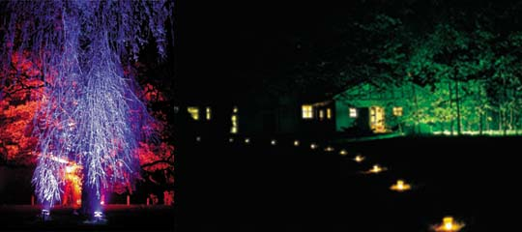
The work and discussions in this group were interesting in that there were very few obvious points of reference in the park that would provide orientation in the dark. The main task in the first working phase was therefore to locate points of reference and, in the second phase, to define how they could form the basis for a lighting concept.
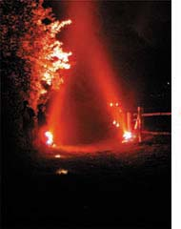
After a brainstorming session the chosen points of reference were listed together with their inherent associations:
- an old oak tree:
radiated energy, vitality, life
- a second large tree with long, low branches: waterfall
- a path with a fence bordering a meadow: nature and border
- an adjacent house with a window.
Taking these defined objects and areas as a basis, the group had the task of providing lighting for orientation within the park, drawing attention to the above features, and accentuating the borders.
The group decided to bring out the symbolic meaning of the two trees by realising the illumination in intensive shades of red and blue. The group had discovered a completely different way of viewing trees: standard presumptions (and colours) were disregarded, and new, more profound aspects of the elements sought. In spite of its age, the oak stands for energy and vitality. The group decided to use red light to symbolise this interpreta-tion: red for blood, blood flowing through our veins, giving us life. In the daytime, the old oak was a still object, the sap flowing through its trunk and branches invisible to the onlooker.
The second large tree was associated with a waterfall. Blue halogen light, enhanced by the use of a blue filter underlined the idea of a flowing waterfall. The general public were most impressed by these installations.
The path from the Ensemble (see above) to the park was lit by small tea candles, an effective and highly functional solution. The vegetation bordering the park behind the bulls' stable was lit by a projector equipped with a green filter. This provided the backdrop to the park, and defined the limits of the space. The window of an adjacent house was lit from inside in red, representative of a witch's house in the woods. The other side of the red and blue trees was bordered by the installation set up by the 'Water Group'. Tea candles were also applied the length of the 200-metre path leading down to the lower end of the meadow and the boundary to the grounds. At the lower end of the path the group created an arched entrance made of red light.
This group's installations clearly showed a new form of lighting design: event lighting. The installations were designed to make people think and wonder. The visitors expressed amazement at the lighting effects, and long discus-sions ensued where individual interpretations were argued.

